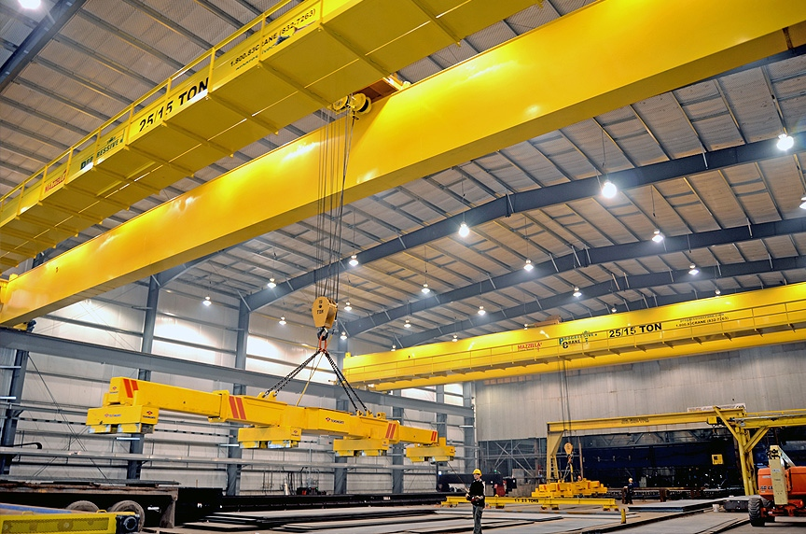

**YOUR LIFTING SOLUTIONS**

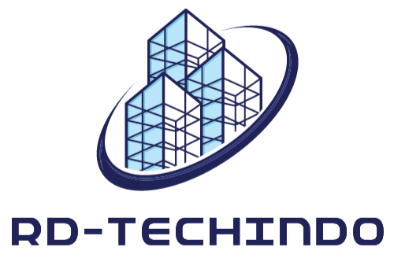

### OVERHEAD CRANE CATALOG

**High Quality, Reliable and Cost Effective Solutions**

**Single Girder Gantry Crane**

Standardized and Custom Engineered up to 50 Tons.

###### Double Girder Gantry Crane

**1**

**JAN 2023**

**Volume**

Standardized and Custom Engineered up to 100 Tons.

## TABLE OF CONTENTS

**Table of Contents 1**

**Letter from the Director 2**

**Semi Gantry Crane 3**

**Single Girder Overhead Crane 4**

**Double Girder Crane 5**

**Jib Crane 6**

**Stacker Crane 7**

**Wall Crane 8**

**Pricing 9**

**Key Gym Advertisement 10**

1

## LETTER FROM THE DIRECTOR

Jan 02, 2023

Dear Our Costumer,

With the permission of the almighty god, and with great gratitude I personally want to express thousands of thanks to all of our costumer.

I am as the leader of this company, always have the main principle in doing business, for me and also for us, customer satisfaction is our top priority.

I personally thank all of our customers who have trust us as your company business partners.

Sincerely, Rusdiansyah

2

**SEMI GANTRY CRANE**

##### By RD-TECHINDO

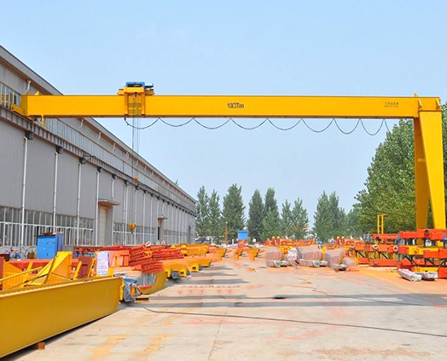

Our semi gantry crane is solutions for your business, this crane type will very helpful your business specially for loading and unloading goods or material from or to trailer and truck.

We provide standardize or engineered semi gantry crane from 5 to 50 Tons SWL.

3

Also we give you 3 years warranty for all of the component, because we give to you very high quality for all the component.

**SINGLE GIRDER OVERHEAD CRANE**

##### By RD-TECHINDO

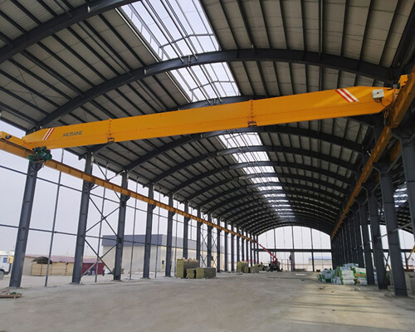

Our single girder crane is solution for your business, this crane will very helpful your production or workshop worker to moving like a machine, material, or heavy things in your working site.

What business usually using this crane is, metal stamping industry, plastic molding manufacture, fabrication workshop, etc.

We provide standardize or engineered single girder crane from 5 to 50 Tons SWL.

4

Also we give you 3 years warranty for all of the component, because we give to you very high quality for all the component.

**DOUBLE GIRDER OVERHEAD CRANE**

##### By RD-TECHINDO



5

Our double girder crane is solution for your business, this crane will very helpful your production or workshop worker to moving like a machine, material, or heavy things in your working site.

What business usually using this crane is, metal stamping industry, fabrication workshop, marine workshop, etc.

We provide standardize or engineered single girder crane from 10 to 100 Tons SWL.

Also we give you 3 years warranty for all of the component, because we give to you very high quality for all the component.

##### REACH YOUR GOALS

$ 100

Know how to reach your goals.

##### BUILD YOUR HABITS

$ 200

Learn how to build good habits.



###### KNOW YOURSELF

$ 200

Find out your strengths and weaknesses.

5

**GL AGENCY**

**We’ll advertise your business.**

#### Promoting your business.

We create ebooks, infographics, annual reports, and others!

We provide content strategy and marketing strategy. 222 555 7777 | [glagency@zmail.com](mailto:glagency@zmail.com) | @glagency

# FINANCE TRAINING

8

##### By Olivia-Grace Taylor



Being knowledgeable about finance matters. If you work in HR, you need to know about handling the payroll, budget, and many others. Another thing, you also have to be knowledgeable when it comes to project budgeting, pricing, and many others as part of running the business.

And if you need some help with these things, we have prepared some finance

training. Each training is easy to learn and apply. All you have to do is to choose and register to your choice.

BASIC FINANCE IN BUSINESS

$ 230

Know the basics in

business finance.

PAYROLL LAW

$ 250

Be knowledgeable in terms of payroll.

9

**LABOR COSTS**

$ 210

Understand how to budget labor costs.

##### PRICING

$ 230

Price your newest products and services in the market.

##### BUDGETING

$ 190

Learn how to budget your business’s money.

10

##### PURCHASING

$ 180

Know the tips on what to and not to purchase.

### KEY GYM

**BE FIT**

#### Be a gym member today!

Personal training, yoga, and weight training.

Visit us now!

222 555 7777 | [keygym@zmail.com](mailto:keygym@zmail.com) | @keygym

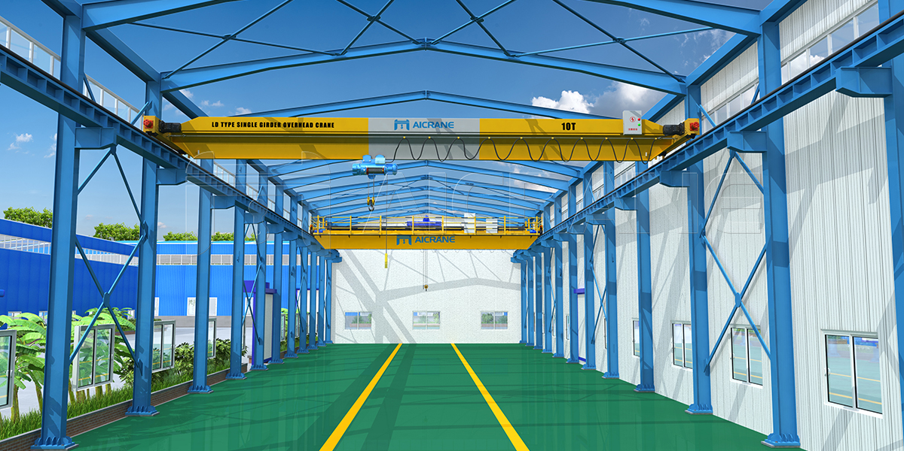



**Office : Jln. Letjend Suprapto, Komplek Bambu Kuning,**

**Batu Aji,Batam, 29424**

**Indonesia**

**Workshop : Jln. Brigjen Katamso, KM 6, Tanjung Uncang,**

**Batu Aji, Batam, 29424**

**Indonesia**

**Contact Us**

**+62 811-601-0218**

[**rdtechindo@outlook.com**](mailto:rdtechindo@outlook.com)